ONGSHAK
Engineering a Smarter Tomorrow
STATEMENT OF WORK
Website Enhancement — Segment 1
Vida Verde Centro de Español | Quito, Ecuador
Prepared by
Ongshak | ongshak.com
Date: April 29, 2026
Version 1.1 | Confidential

1. Parties & Effective Date
This Statement of Work (“SOW”) is entered into between:
Service Provider: Ongshak, a digital technology and software services firm based in Dhaka, Bangladesh, represented by Ridwan Hossain, Co-founder (“Ongshak”).
Client: Vida Verde Centro de Español, a Spanish language education provider based in Quito, Ecuador (“Client” or “Vida Verde”).
Effective Date: Upon mutual signature of this SOW.
This SOW operationalizes Segment 1 of the development proposal dated March 24, 2026 (“Proposal”). Segment 2 (LMS Development) is outside the scope of this SOW and will be governed by a separate agreement.

2. Scope of Work
Ongshak will enhance the existing vidaverde.com website to deliver a modern, mobile-first, conversion-optimized experience while preserving Vida Verde’s brand identity and existing service catalog.

2.1 Design & Visual Refresh
- Modern UI overhaul — refined typography, color palette, spacing, and imagery treatment.
- Mobile-first responsive design across phone, tablet, and desktop breakpoints.
- Removal or replacement of broken page elements (e.g., non-functional Twitter widget).
- Consistent visual treatment for hero imagery, gallery sections, and teacher profiles.

2.2 User Journey Optimization
- Simplified navigation architecture and program discovery flow with filterable course catalog.
- Self-service booking funnel with calendar-based scheduling and automated confirmations.
- Refreshed trust signals — testimonials, AECEE certification, student count, About Us narrative.
- Lead capture surfaces — free trial CTAs, newsletter signup, downloadable learning guides.
- Floating WhatsApp inquiry button.

2.3 Technical Improvements
- Performance optimization — image compression, lazy loading, caching, CDN setup.
- SEO foundation — meta tags, structured data, Open Graph, sitemap.
- Bilingual English/Spanish toggle with SEO-friendly URL structure.
- Stripe payment gateway integration replacing PayPhone (~2.9% vs. 6.1% commission).
- Google Analytics 4 with conversion and event tracking.
- Modern blog layout with categories, tags, and sharing controls.

3. Visitor → Enrolled Student Journey
This section describes the five-stage conversion funnel that the enhanced website is designed to optimize. Each stage maps to a specific visitor goal and the website features delivered under Section 2 that support it. The journey reflects how a prospective student moves from first awareness to confirmed enrollment, and the friction points the enhancement removes along the way.
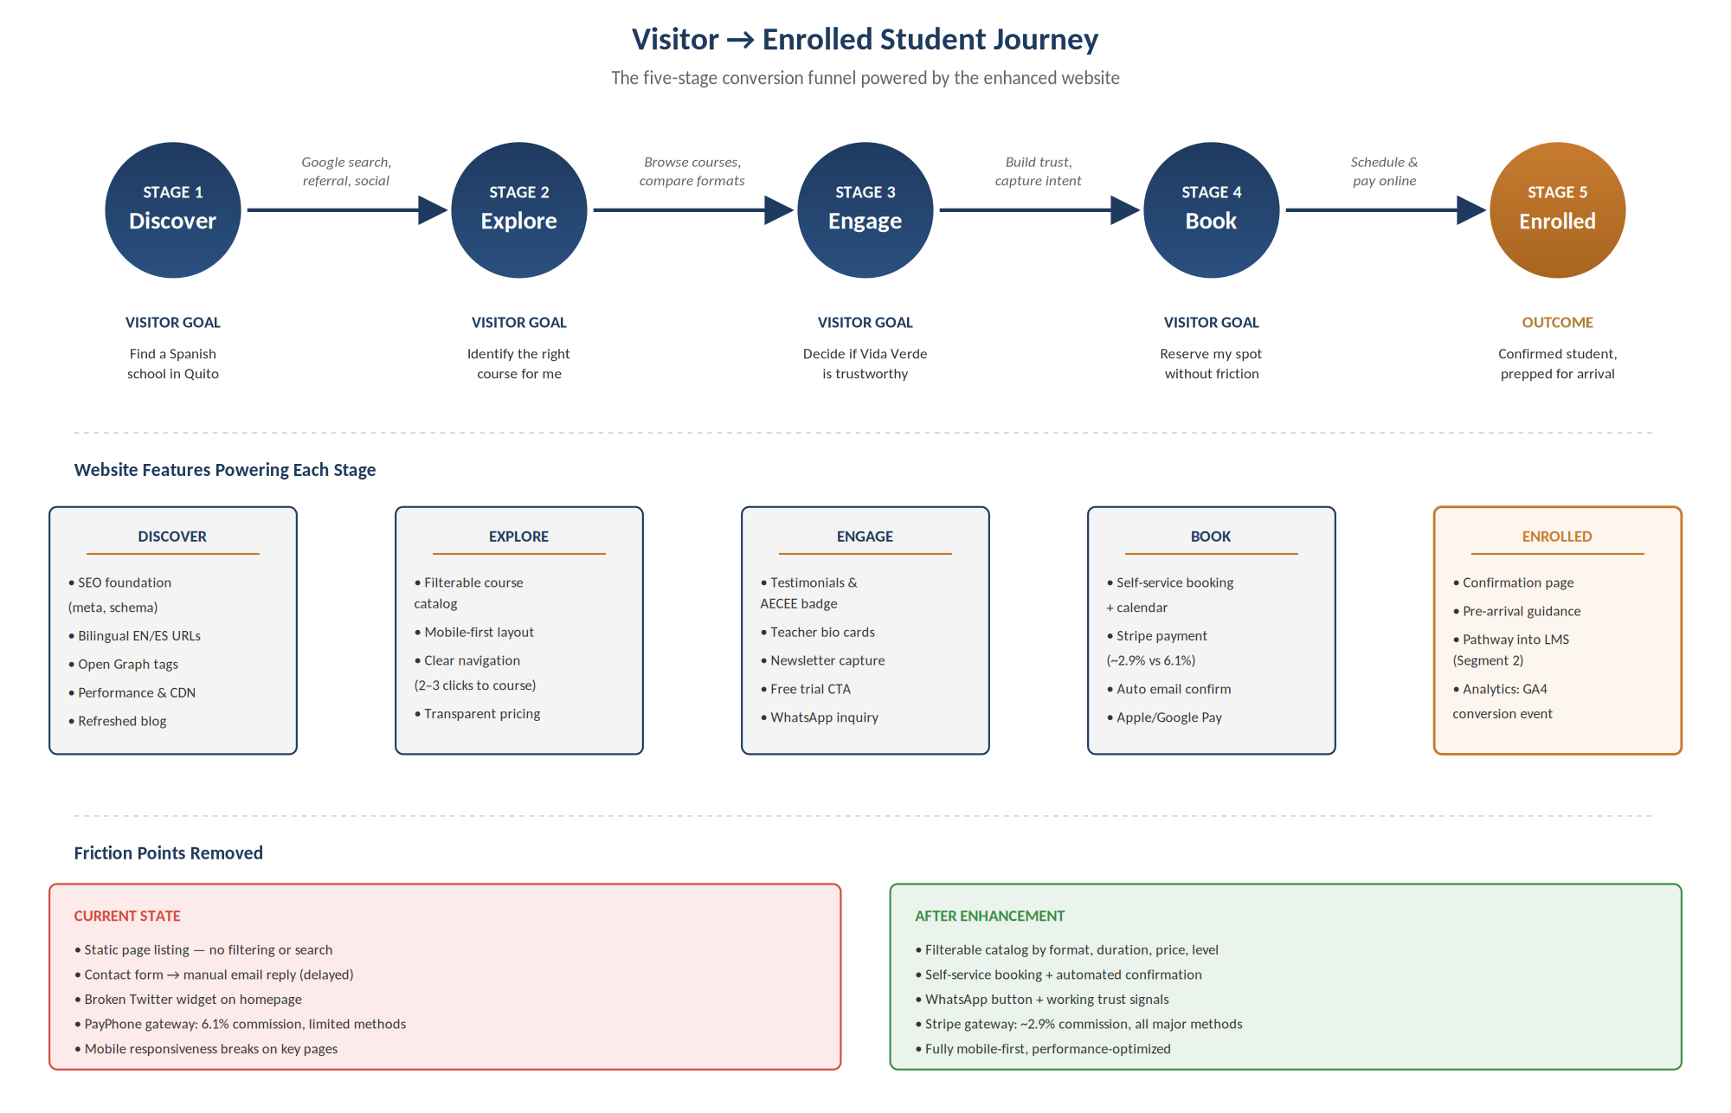
The five stages — Discover, Explore, Engage, Book, and Enrolled — each correspond to specific deliverables in the project scope. Stages 1 through 4 represent visitor decision points where the current website creates avoidable friction; Stage 5 marks the conversion outcome and the entry point for downstream engagement.

3.1 Success Metrics
To measure the impact of the enhancement, the following metrics will be tracked from launch via Google Analytics 4 and the Stripe dashboard. A baseline will be established during the first 30 days post-launch:
- Conversion rate from website visitor to booking inquiry (Stage 3 → Stage 4).
- Conversion rate from booking inquiry to confirmed payment (Stage 4 → Stage 5).
- Average time from first site visit to enrollment confirmation.
- Mobile vs. desktop conversion split.
- Drop-off rate at each funnel stage.
- Effective payment processing cost as a percentage of transaction volume.

4. Deliverables & Timeline
The Segment 1 engagement is structured across four sequential phases over an estimated six (6) calendar weeks from kickoff to launch. Each phase concludes with a defined deliverable and Client review checkpoint.
Phase | Milestone | Deliverables | Duration
1.1 | Discovery & UX Audit | Stakeholder interviews, user journey mapping, content audit, wireframes, sitemap | 1 week
1.2 | UI Design | High-fidelity Figma mockups for all key pages, responsive breakpoints, style guide | 2 weeks
1.3 | Development & Integration | Frontend build, CMS setup, booking engine, payment gateway, bilingual content, SEO | 2 weeks
1.4 | QA, Testing & Launch | Cross-browser/device testing, content review, performance checks, go-live | 1 week

Phase durations assume timely Client feedback (within two business days per review cycle) and uninterrupted access to required content, brand assets, and platform credentials.

5. Investment & Payment Terms

5.1 Total Investment
Component | Amount (USD)
1.1 Discovery & UX Audit | $180
1.2 UI Design (Figma mockups, style guide) | $375
1.3 Development & Integration | $535
1.4 QA, Testing & Launch | Included in 1.3
Total — Segment 1 | $1,090

5.2 Payment Schedule
Payment will be made in three milestone-based installments:
Milestone | % of Total | Amount (USD) | Trigger
1. Signing | 40% | $436 | Upon execution of this SOW
2. Design Approval | 30% | $327 | Upon Client sign-off on Phase 1.2 mockups
3. Launch | 30% | $327 | Upon production go-live (Phase 1.4)

5.3 Payment Method
All payments will be made via international bank wire transfer (SWIFT) in United States Dollars (USD) to Ongshak’s nominated bank account. Wire transfer details will be provided on each invoice.
Bank charges: Each party bears its own bank charges. Client’s remitting bank fees are paid by Client; Ongshak’s receiving bank fees are paid by Ongshak. Any intermediary correspondent bank charges shall be borne by the Client (OUR fee instruction).
Invoicing: Ongshak will issue an invoice on each milestone trigger. Payment is due within seven (7) business days of invoice receipt.
Late payment: Work on subsequent phases will be paused if a milestone payment is more than ten (10) business days overdue.

6. Client Responsibilities
To enable on-time delivery, Vida Verde will provide:
- Administrative access to the current WordPress installation, hosting environment, and domain registrar.
- Brand assets — logo files, photography, color references, typography preferences.
- Content for all key pages, including teacher bios, course descriptions, testimonials, and pricing.
- A designated primary point of contact for day-to-day communication and approvals.
- Timely review and feedback on each phase deliverable (within two business days per cycle).
- Stripe account setup or authorization for Ongshak to assist with account creation.

7. Assumptions & Exclusions

7.1 Assumptions
- The current WordPress site will be retained as the underlying platform; no migration to a different CMS is included.
- All existing service offerings, course structures, and pricing remain unchanged unless otherwise instructed by the Client.
- Bilingual content (English and Spanish) will be supplied by the Client in finalized form, or a content writing scope can be added separately.
- The Client owns or has rights to all photography, imagery, and content provided to Ongshak.

7.2 Out of Scope
- Segment 2 — LMS Development (covered under a separate agreement).
- Original photography or videography production.
- Translation services for content written in only one language.
- Paid advertising campaigns, ongoing SEO services, or content marketing operations.
- Native mobile app development (iOS/Android).
- Third-party software license fees (e.g., premium WordPress plugins, stock imagery, fonts) — these will be passed through at cost with prior approval.

8. Change Requests
Any modifications to scope, deliverables, or timeline beyond what is defined in this SOW will be handled through a written Change Request, signed by both parties before work commences. Ongshak will provide a written impact assessment covering effort, cost, and timeline implications within three (3) business days of receiving a change request.
Minor revisions within the spirit of the original scope (typically under two hours of effort) will be accommodated without a formal Change Request at Ongshak’s discretion.

9. Intellectual Property & Post-Launch Support

9.1 Ownership
Upon receipt of full payment, all custom code, design files, and content produced specifically for Vida Verde under this SOW transfer to the Client. Ongshak retains the right to reference the project in its portfolio (including screenshots and a public link) unless the Client requests otherwise in writing.
Third-party components (open-source libraries, plugins, frameworks) remain governed by their respective licenses.

9.2 Post-Launch Support
Ongshak will provide three (3) months of post-launch support at no additional cost, beginning the day of production go-live. Support covers:
- Bug fixes related to scope delivered under this SOW.
- Minor adjustments and content updates (up to four hours per month, non-cumulative).
- Technical guidance via email and scheduled video calls.
Ongoing hosting, maintenance, and feature additions beyond this period will be governed by a separate annual maintenance agreement.

10. Confidentiality & Termination

10.1 Confidentiality
Both parties agree to treat all non-public business, technical, and commercial information shared during this engagement as confidential and to use such information solely for the purposes of this SOW.

10.2 Termination
Either party may terminate this SOW with fourteen (14) days’ written notice. In the event of termination:
- The Client will pay for all work completed up to the termination date, prorated against the milestone schedule.
- Ongshak will deliver all work-in-progress assets in editable format within five (5) business days of receiving the final payment.
- Confidentiality obligations survive termination.

11. Acceptance & Signatures
By signing below, both parties acknowledge that they have read, understood, and agreed to the terms set forth in this Statement of Work.

FOR ONGSHAK  Md Ridwan Hossain  Co-founder, Ongshak  Date: ____________________ | FOR VIDA VERDE CENTRO DE ESPAÑOL  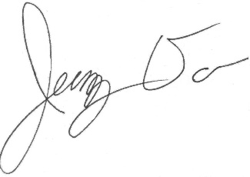  ____________________  Authorized Representative  Date: ____________________

Contact
Md Ridwan Hossain | Co-founder, Ongshak
Email: ridwanhpatwary@gmail.com
Website: ongshak.com
Location: Dhaka, Bangladesh

